Assignment 1

Question 1

What will the code below output to the console and why ?

console.log(1 + "2" + "2");

console.log(1 + +"2" + "2");

console.log(1 + -"1" + "2");

console.log(+"1" + "1" + "2");

console.log( "A" - "B" + "2");

console.log( "A" - "B" + 2);

Answer:--

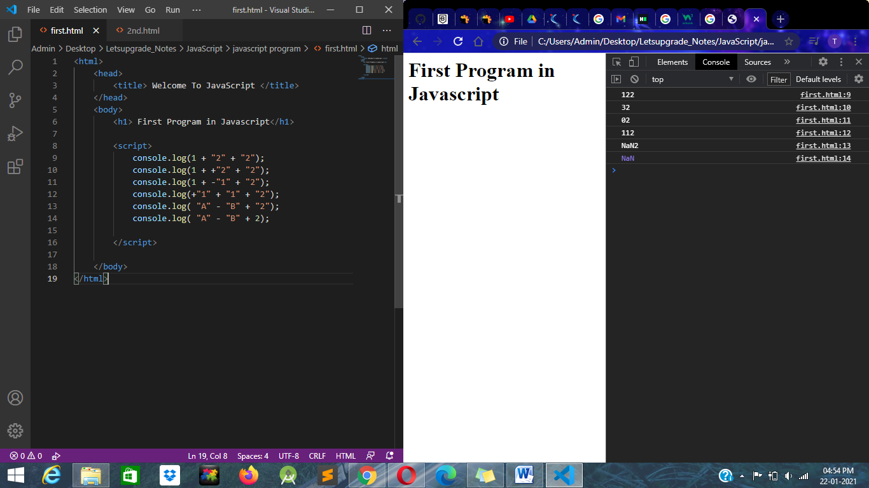

Question 2

You are given a variable “marks”. Your task is to print:

- AA if the mark is greater than 90

- AB if the mark is greater than 80 and less than or equal to 90

- BB if the mark is greater than 70and less than or equal to 80

- BC if the mark is greater than 60 and less than or equal to 70

- CC if the mark is greater than 50 and less than or equal to 60

- CD if the mark is greater than 40 and less than or equal to 50

- DD if the mark is greater than 30 and less than or equal to 40

- FF if the mark is less than or equal to 30

Answer:--

